

GUILDWARS 2 Dragons Stand Meta South Lane Guide

Things you need to know about the South Lane of Dragon Stands Meta.

By Nersyss AKAMarta

guardian of the united[gotu] & Exodus/z of the elder dragons/z[GODS]   EU based

**South Lane xx:30**

**IMPORTANT**

* **SOUTH** **- Legendary Axemaster Hareth:** heavily armoured (you have to break his CC bar), spins, creates fissures on the floor which are deadly.
* **Do not CC the Mouth of Mordremoth.** If as minimal CC as possible you can 1 Shot the boss with high DPS

**EVENTS x2**

**- Defend Splort as he activates lasers:** You have to escort Splort, on each laser groups of mobs will spawn, and on the final one also a Veteran Chak.

**- Destroy ley-line collectors to gather energy for the Rata Novus device:** To startthe event you have to talk to Dunka. You have to follow the NPC, then you have to destroy collectors to get ley energy (from 1 collector you get 2 of them). Those collectors are located around the room, you can get to the different platforms using bouncing mushrooms. Once you gather them you have to deposit them on a device on the platform on top. Be careful with the chaks, there’s some on each platform. This event scales easily, the more people the more energy you need; for this reason only around 8 players are needed. If the event succeeds you will have access to golems.

*Since the ley line event scales easily only a little group will do it, the rest have to follow the commander. Once the squad is done with the escort, they have to wait for the ley line event to finish, do not join them.*

**ESCORT**

On the escort first you will face the Thornheart (*arrow mark*) and then the stalkers, around the area where the lasers event finished (*X mark*).

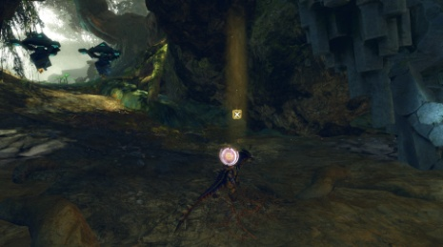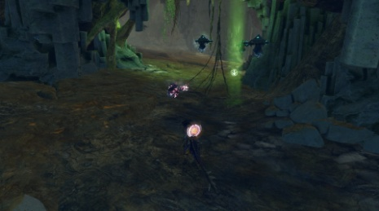

**SPITFIRE & VINETENDERS**

Here you have to focus on the Wurm Boss and DPS it as soon as the shield disappears. Some Vinetenders will spawn around it, you have to kill them or else they will put the shield on the boss again. They are protected by some mobs.

**EVENTS x2**

**- Escort Dolyak to the camp before escort:** The event starts on the First Southern Checkpoint. You have to escort a dolyak till the second camp; some mobs will spawn along the way. Near the camp a Champion Mordrem will appear. Around 5-6 players are enough for this event. If the event succeeds you will have access to Charr weapons.

**- Kill the Chak preventing the pets from returning to their ogre masters:** You have to enter the Chak nest and look for pets that are being attacked by the chaks. Sometimes you will need to destroy some kind of walls to have access to new tunnels. Players have to spread to the different spawn areas.

**ESCORT**

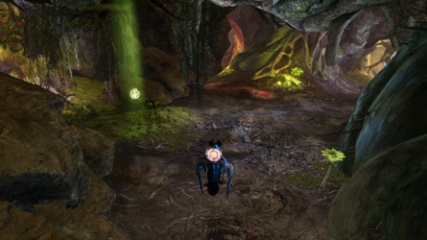This time the Thornheart will spawn near the camp on the left (*arrow mark*). After it you will face the Legendary Axemaster. The stalkers spawn near the next Spitfire, and depending on where you are fighting the boss maybe they also join.

*The Thornheart spawns after a big rock on the left.*

**SPITFIRE & PRESERVERS**

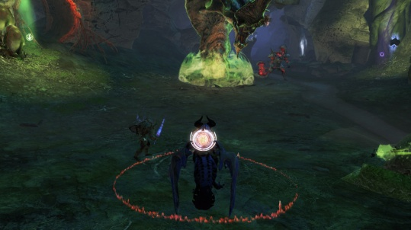After the escort you will face another Spitfire. This time before the boss you have to kill the preservers, which will spawn near it. If they reach the Wurm they will restore its health, so kill them fast. The first one spawns on the left (*arrow mark*), and the second one on the right near the WP (*circle mark*). After defeating them use full DPS on the Wurm Boss.

If you want to try, there’s another option, to kill the Wurm Boss before the preservers reach it, but you need to have a lot of DPS!

**EVENTS x2**

**- Protect Skeln Razorfist while he builds thumpers:** You have to escort the NPC, on each spot some mobs will spawn.

**- Calm angry beetles down by stomping nodules inside the Chak Nest:** Poison Mastery is needed for this event. You have to calm the beetles by luring them to some nodules. If you stomp the nodules when a beetle is within its range it will calm down.

*An option for this phase is to send around 8 people to the beetle event and then the rest follow the commander. Once the escort event is done the squad can stay near the tower and wait for the Legendary Axemaster to appear. You can ask the players on the beetle event to stay with the final escort when they finish their event.*

**ESCORT**

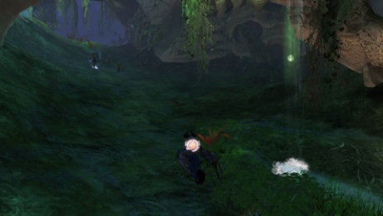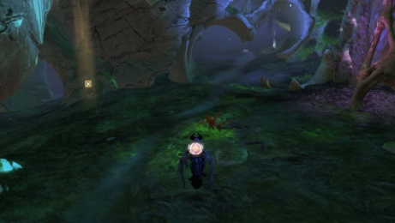During the final escort first you will face the stalkers; they spawn on the left of the path (*X mark*). After defeating them and a bit closer to the tower, the Thornheart will spawn on the right (*arrow mark*).

**TOWER**

When all the lanes reach the gates the next phase starts. Here you will enter a circular room with a platform in the middle where there is one of the Legendary Bosses. Around the platform 3 Ley Line Pods will spawn; the boss will be invulnerable till you destroy them. Those collectors are protected by 3 preservers that can restore them or even respawn them.

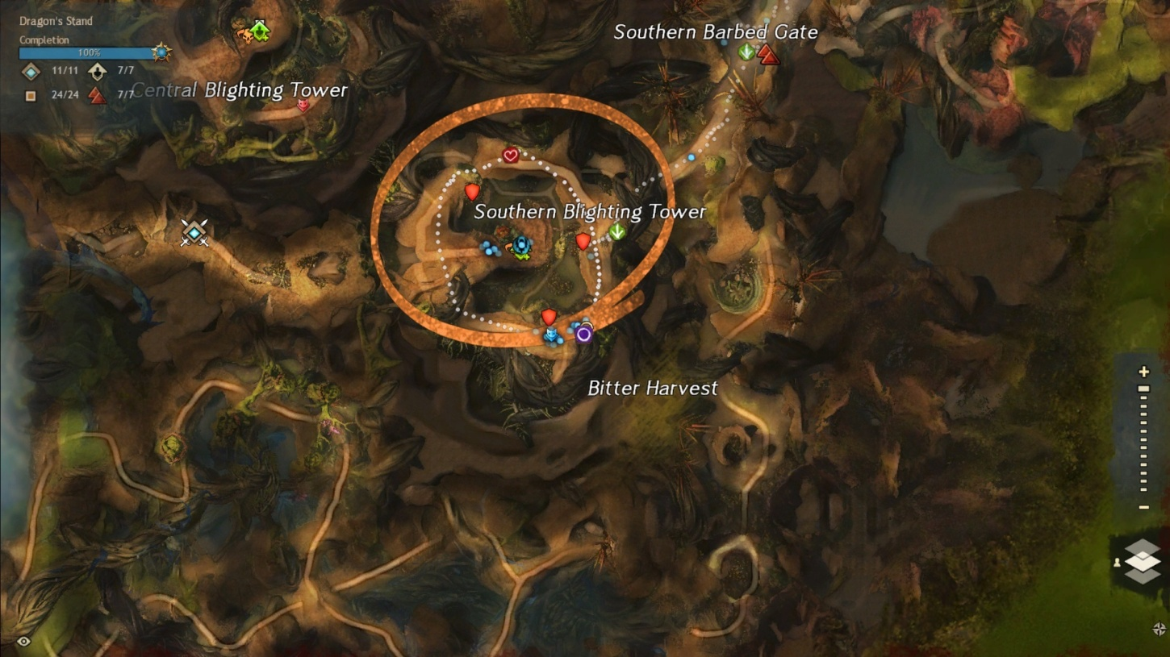You will need two groups; a little group of around 10 players will go to the middle and kill the Boss, and the main one will follow the commander around the room destroying the collectors and the preservers. Even if the collectors are destroyed the preservers will keep spawning, so the group must keep running and killing them; use CC on them so it’s easier to do so. Full dead players should use the WP since it will be very difficult to revive them, and using swiftness really helps on this phase, a slow rotation can cause the collectors to spawn again. If the collectors respawn the Boss will be invulnerable again, or even revive if it was already killed.

*Shields:* ***Collectors***

*Arrow, circle and heart marks:* ***Preservers’s*** *spawn location*

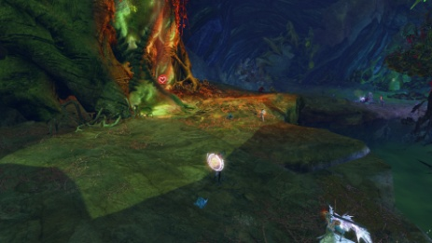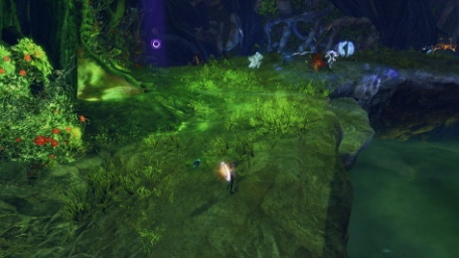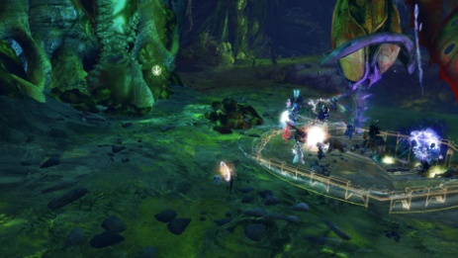

AFTER TOWERS:

**Against the Mouth of Mordremoth**

You will enter a large space of 9 islands, 3 for each lane. The players have to spread across them. The Updraft Mastery is required for this phase, and having Ley Line Gliding mastery makes everything a bit easier since the islands are connected by energy flows.

On this phase you will face different events. In different occasions the **Mouth of Mordremoth's** **head** will attack one island, and at the same time the **dragon’s** **body** will be near another island. Each squad has to go to the nearest. It’s a short attack and you have to be careful with their attacks. The head can do different attacks: fear players, drop bombs or smash the island (for this one look for when the heads goes quite above the island, you have to get off the island or it can instakill you). Some other events that can happen are:

* Destroy the ley-line disruption pods
* Destroy the vine growth: if the event fails a part of the island is destroyed
* Defeat the Mordrem Commanders: the three Legendary Bosses will spawn one on each island.

The important event on this phase is when the Mouth of Mordremoth's head attacks an island and at the same time bombs spawn on another one. The fightwill be longer and is the perfect chance to do as much damage as you can. On this part some bombs spawn on a random island; players near it have to go there and pick one to throw it to the head (don’t throw it when the blue bar is up). Bombs do most of the damage so it’s important to bring as many as possible; you can use the WP to move while holding a bomb. It’s really important not to use CC to have time for the bombs to get to the head.

**Squad chat**

*xx:25 🡪* Mount up until xx:30 so you don’t die. Also at xx:30 map will reset so join fast my instance to get a place into the map. Map will get full fast.

If we end up in a different map than the rest of the Commanders I will swap instances. If that’s the case I will tell.

*1 min left 🡪* Mount up to not die, or use a chair if you have one.

**EVENTS x2**

So 6-8 players max go to the Ley Line event please.

Everyone else who isn't going to Ley Line please follow me with the escort and then come back to start and wait there. Don’t go to the Ley Line event, it scales easily.

**ESCORT**

Thornheart will spawn at arrow. Use your bunny. This boss will need a lot of CC at first.

Stalkers will spawn around X mark, kill them fast.

**SPITFIRE & VINETENDERS**

Full DPS the Wurm Boss when it is unshielded. Kill Vinetenders when they spawn, they put a shield on the wurm.

**EVENTS x2**

Some ppl (around 6) go back to start and do the dolyak escort. The rest come with me to rescue the pets.

Legendary Axe Master – CC blue bar and Ranged is preferred. Golem Suits also deal a lot of CC, melee people use them (if we got).

**ESCORT**

Stalkers will spawn around X mark, kill them fast.

Thornheart will spawn at arrow. Use your bunny. This boss will need a lot of CC at first.

**SPITFIRE & PRESERVERS**

This time we kill preserver first, first arrow and then circle. Then full DPS the Wurm Boss. If the preservers reach the Wurm they will restore it, so we have to kill them fast.

**EVENTS x2**

Some ppl (around 8) go to beetles event. The rest with me to escort.

For the beetles you will need poison mastery. Lure the beetles to mushrooms and smash them.

**ESCORT**

Stalkers will spawn around X mark, kill them fast.

Thornheart will spawn at arrow. Use your bunny. This boss will need a lot of CC at first.

**TOWER**

For the tower phase we need to kill some preservers (and collectors) and also kill the boss on the middle.

Some volunteers go to group 2 for the boss, max 10. Group 1 with me will rotate and kill preservers. Group 2 after you finish join us or help other lanes if needed.

Group 1: After we killed all collectors use CC for preservers and run fast to make sure they don't reach the zone. Run fast to the point that I mark, don’t wait for me and don’t resurrect fully dead players (use WP).

Group 2: Stack the boss to the middle; don’t let it come to us.

**MOUTH OF MORDREMOTH**

Crowd Control Skills (Cripple, Fear, Taunt, Knockback, Knockdown etc.) Please do not use these skills against Mouth Of Moredemoth. ALL Squads also get the BOMBS; throw them when there is no blue bar.